Seminar on Librarianship as a profession
A state level seminar on ’Librarianship as a profession’ organized by Central library in collaboration with IQAC on 12th August, 2022. The speaker was Dr. Subarna Kumar Das, professor, Dept. of Library and Information Science, Jadavpur University. It was a one-day seminar. The programme was inaugurated by lighting the lamp and the speech of our IQAC co-ordinator Dr. Saurabh Bhattacharya, then a short introduction of the speaker by the librarian. The programme was ended successfully with the interaction of the participants with the speaker. There were near about 60 students and almost all the teachers and non-teaching staff of our college.
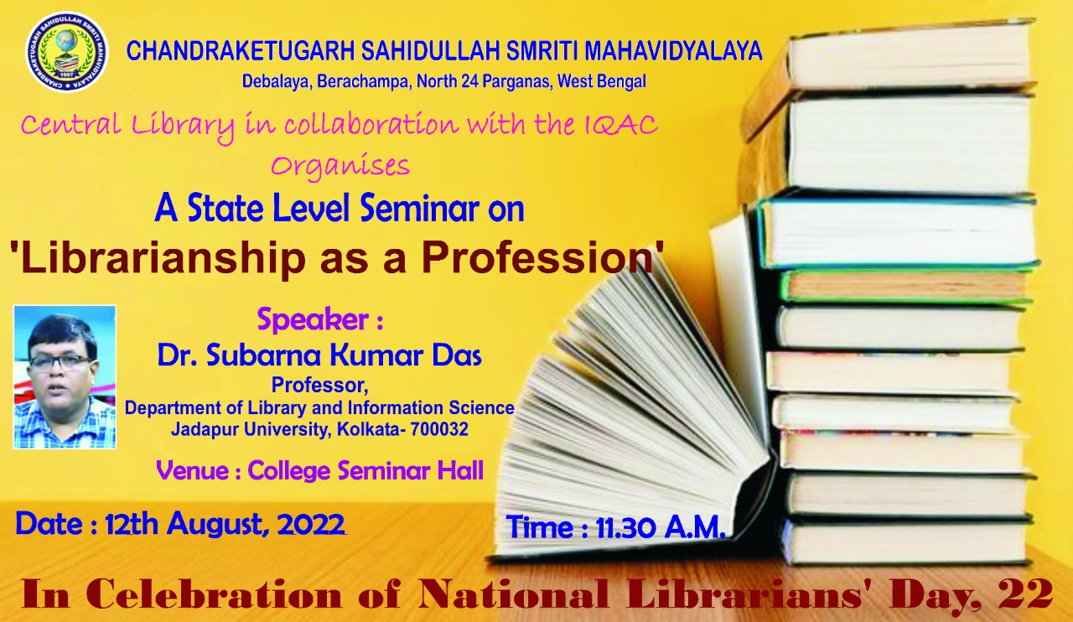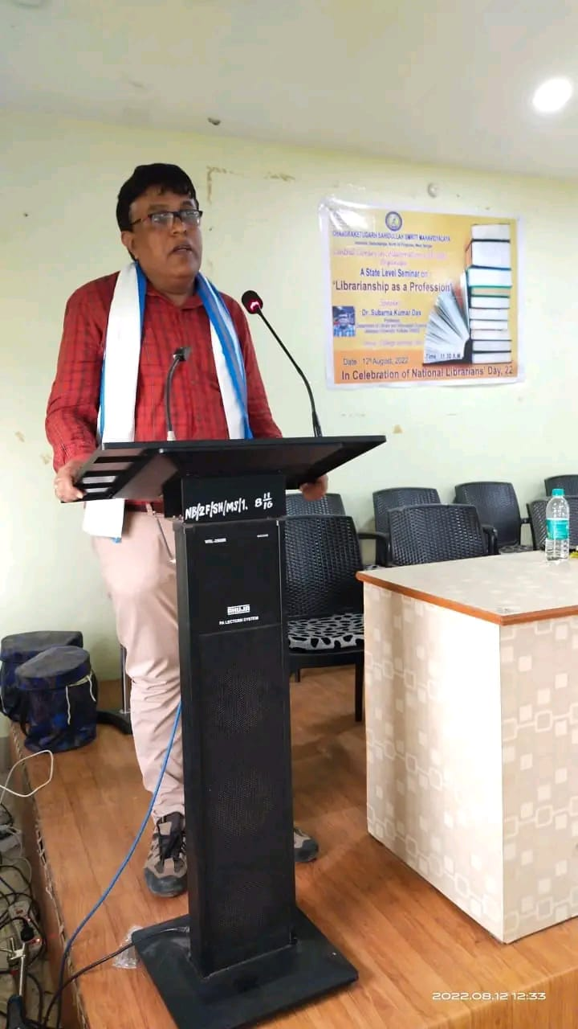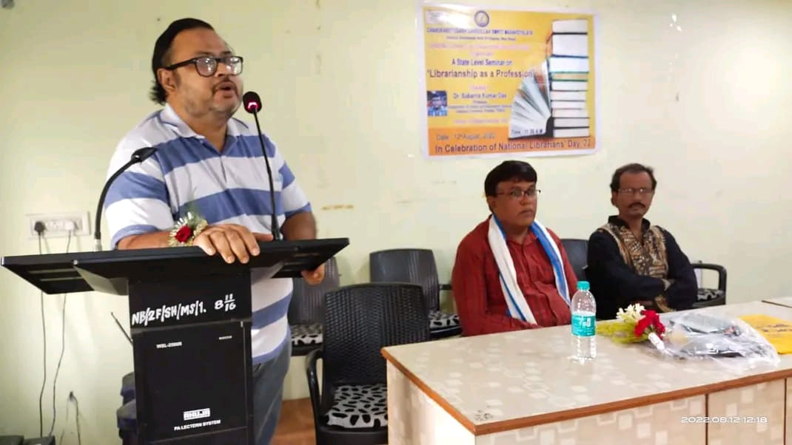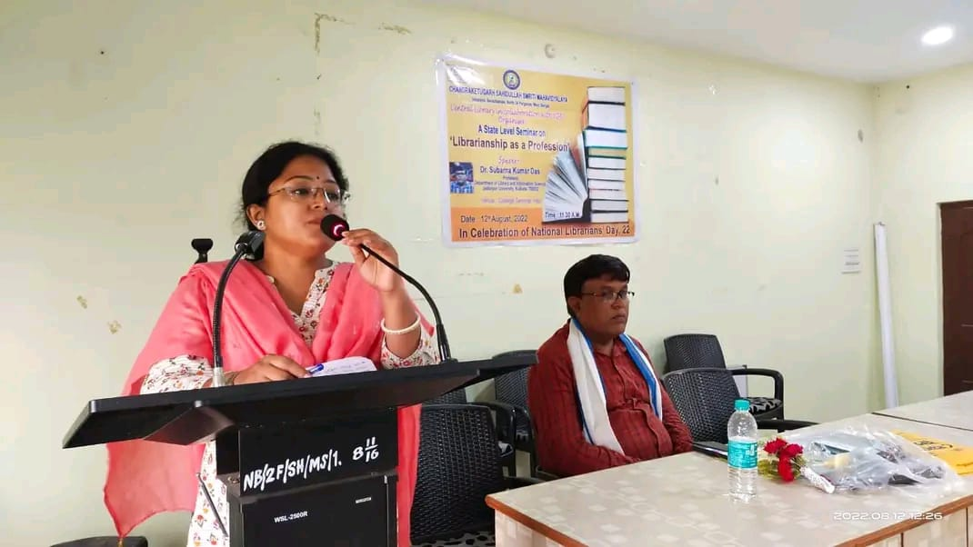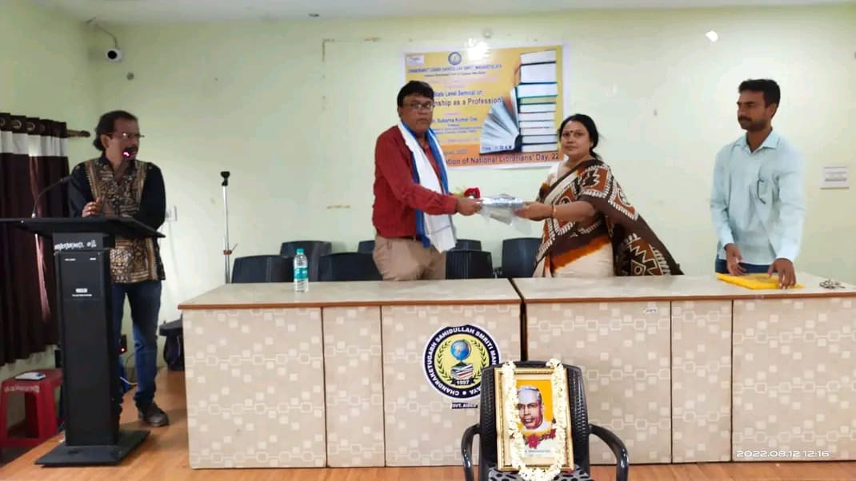

Book Exhibition 2023
A one day book exhibition cum sale programme was organized by the Central library in collaboration with IQAC on 17.03.2023 mainly for the students and staff of our college, though visitors from the local community also came in the exhibition. More than 200 students and almost all our college staff were present there to browse and buy the books. More than 10 publishers came and display their books on UG and PG syllabus as well as other types of books like story books, carrier guidance books etc. Central library purchased books according to the requirements of the students and teachers.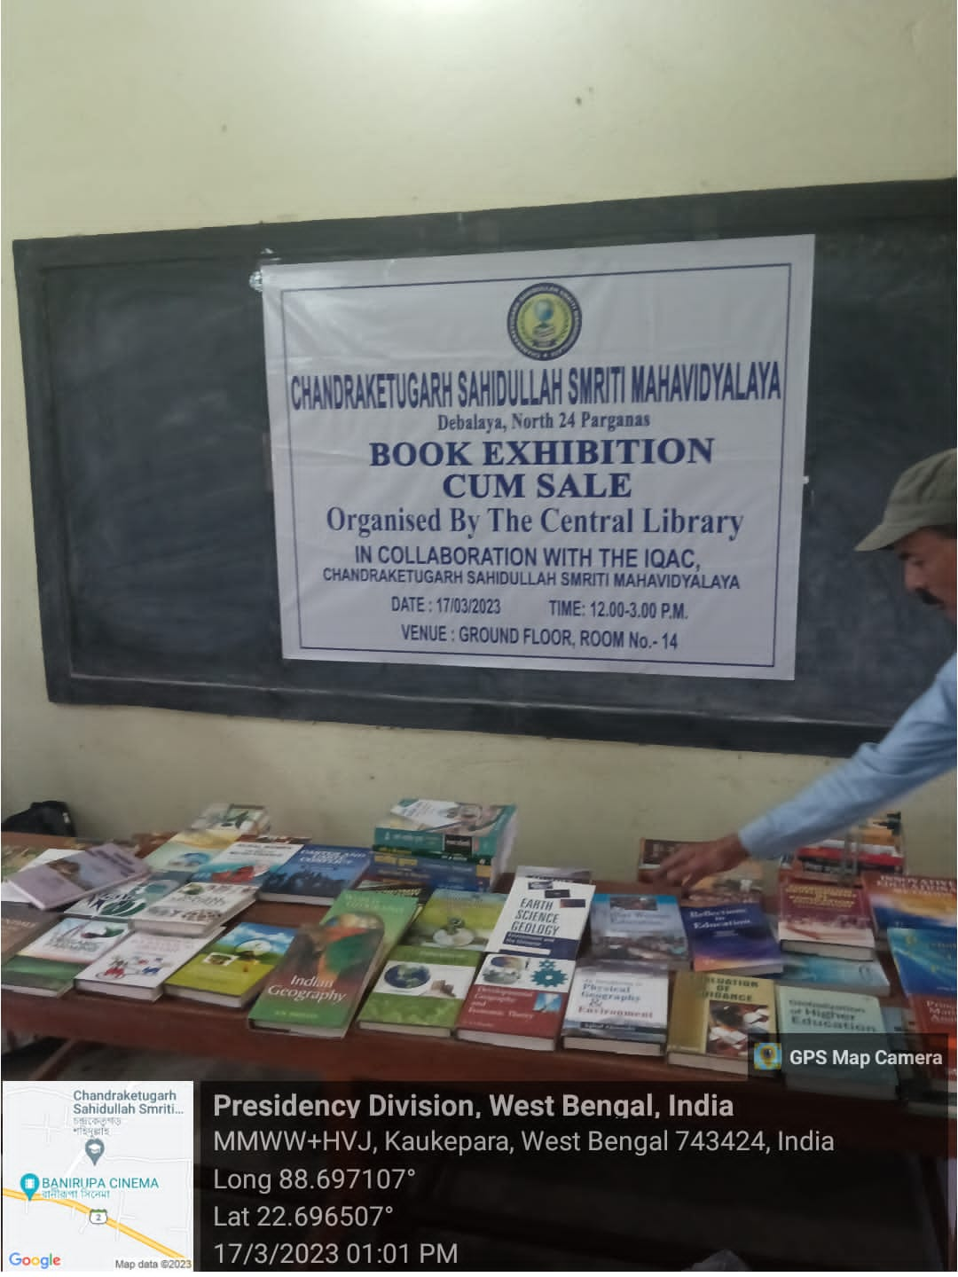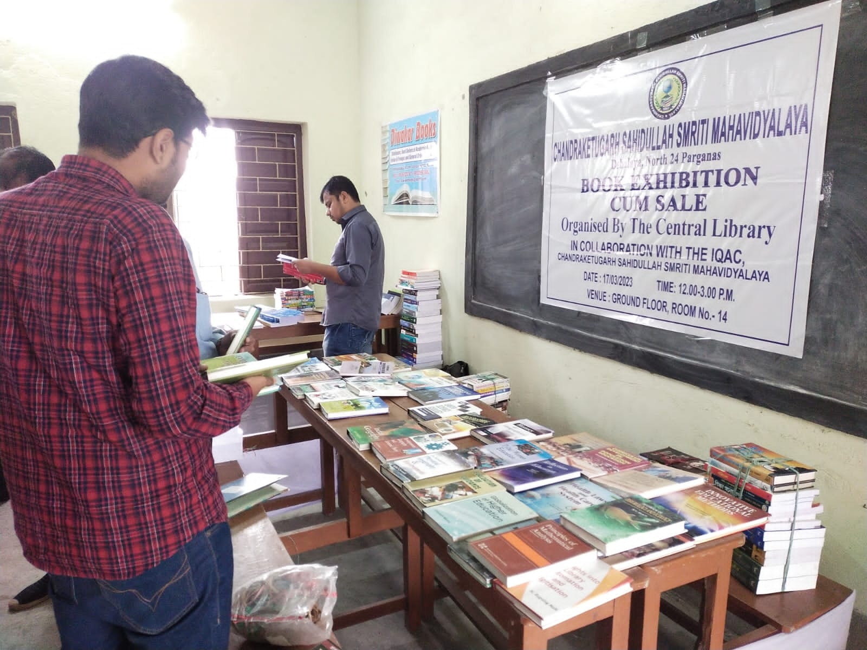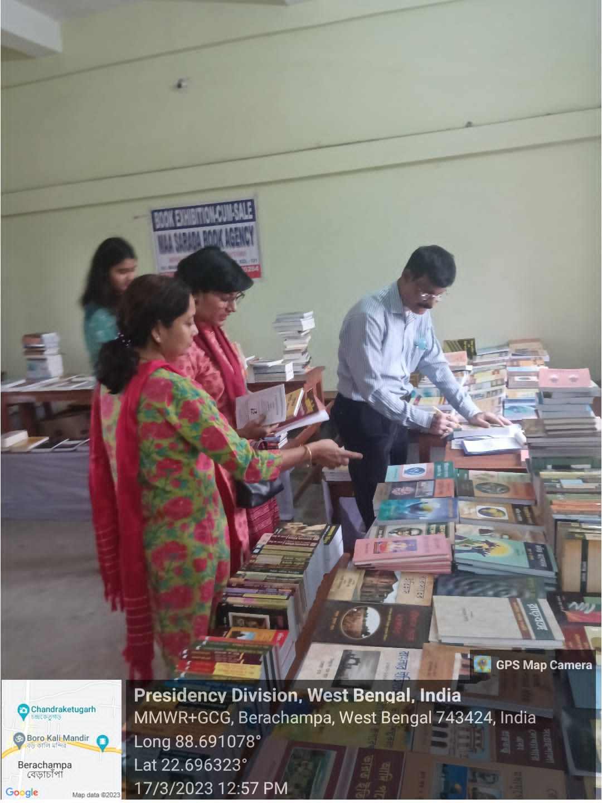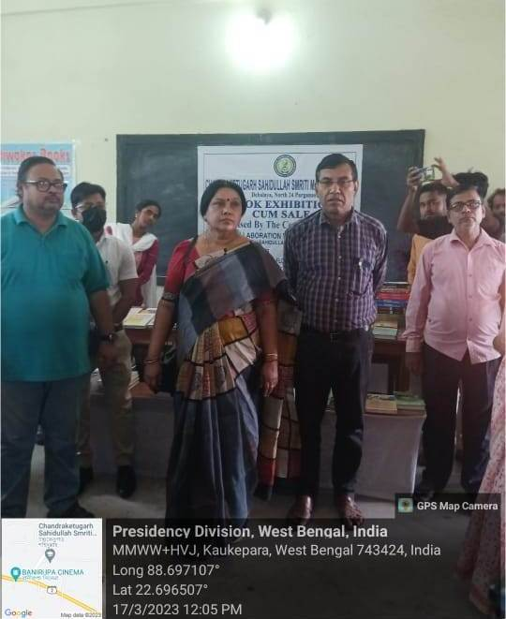

Srijan prohor
Central library organized a creative hour ‘Srijan Prohor’ on 28/02/2023 in the seminar hall of our college. It is a programme for the teaching and non-teaching staff of our college. Almost half of our staff were present and participated actively in the programme and make it successful with their songs, recitations and various other performances.
